Minutes Cherry Park House Management Committee
AGM
Monday 20th May 2024 2 pm

Welcome

Attendees
Richard Lawty, Penny Lawty, Carol de Ridder, Gladys Caolo, Valerie, Gillian Carlsson, Mary Mead,

Apologies
Suzanne Marsh BOI photo, Lyn Read Floral Art, Darryl Jay, Beverley McLeod, Emma Walker.
Move list accepted Penny Seconded Richard

Minutes of 2023 AGM
Move that mins of 2023 AGM be accepted Richard Seconded Carol

AGM 2024 Chairman’s report
Welcome to the CPH 2024 AGM. Thank you for coming.
There have been a few changes in the functioning of CPH this year.
Back at the start of the year, April 2023, we had changes in the Local Council where Frank Owen was replaced by Amy Slack as our Local Board Representative. On the Management Committee Frank Owen took on the Treasurer’s role from Gladys who was temporarily doing it with Emma Walker joining us as a committee member. Unfortunately, after a number of false starts, Frank found himself unable to take on the Treasury role and resigned from the committee altogether, leaving Gladys continuing her temporary role. Now at the end of the year we are faced with the resignation of Gladys from the committee. She has been such a great help to us in so many ways, we are sad to see her go. The CPH committee thanks Gladys for her valuable contribution.

Meanwhile in the FNDC, among the many changes, Darryn James the Asset Manager for District Facilities, left. Darryn had been a major supporter and driving force for seeking a new venue to replace CPH which is to use his words, ‘not fit for purpose.’ So with the loss of Darryn and a gloomy outlook for the current planning, there seems no improvements for CPH going forward.
Other things that happened during the year:
- We had a car crash into our signage which was fortunately repairable.
- We had a break last year in which led to replacement of the entry lock system. We’ve had a year of using the new lock and it seems to be working well.
- The defibrillator mounted in the carpark was vandalised, as was the one held by the Croquet club. St John kindly repaired both for us.
- There is now a new light outside the back entry door included in the security lighting system.
- The insurance arm of Council suddenly demanded we instal fire extinguishers in case of a kiln fire downstairs. There were some in the kitchen and downstairs of uncertain age. New ones have been installed outside the kitchen and downstairs.
- Skedda, the provider of the calendar in the CPH webpage decided to charge us upwards of $50 per month. Although it had a number of features, it was decided that it was not justifiable compared with free applications. We have changed it to using the Google calendar for bookings.
- While in office, Frank requested we change from calendar year to financial year booking to help the Treasurer role. We have started on this path. By April 1st 2025 the financial year will be operating. Thanks to Gladys & Penny for handling the work involved.
That brings me to the conclusion of my report. I wish you all a productive & creative year ahead. Thank you for your participation.

R Lawty Chairman CPHMG
Move that Report accepted Richard
Seconded Gladys
Interim Treasurer Annual Report 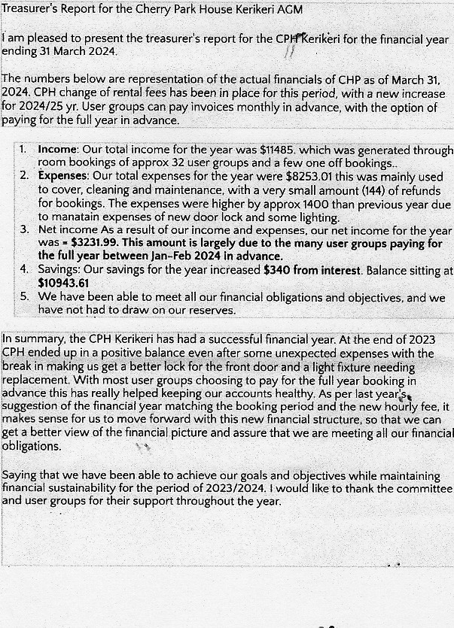Move that Report accepted Gladys
Seconded Richard
Richard thanked Gladys on behalf of CPHMC for her huge contribution to CPH.

Financial reviewer for 2024-2025
Propose Treasurer need to make contact with such.

2024 AGM Booking Report

Thank you, Mr Chairman.
Cherry Park House is pleased to report a mainly consistent and problem free use of our new (Google) calendar on the Website. There has been a need to remind some groups, at times, to refer to the calendar to check availability rather than rely on the Bookings officer to do that.
There has been a drop off, of a few user groups over the past year with a settlement average of 24 active groups and 2 or 3 dormant ones still on the books.
Tuesday and Thursdays are the busiest days and are currently at capacity for booking management.
There has been a positive response to the change of fees to $5 per hour per room. Thank you, user groups for your compliance and participation.
The committee is currently involved in the transition of changing the bookings from calendar year (January to December) to financial year, (April to March). The committee have put forward options on how this works with booking times for 2024 -2025.
Thank you once again for your participation in using Cherry Park House as a facility that accommodates your needs and creative desires. May the forthcoming year be a fulfilling and productive one for you all.
P Lawty Booking officer
Move report accepted Penny Seconded Richard

Election of new committee
There was only one nomination per position therefore members elected without vote
Chairman Richard Lawty
Treasurer Emma walker
Secretary None
Booking officer Penny Lawty
Members, Carol de Ridder
Richard thanked the new committee for stepping up for a new year.

General Business
None

Conclusion of meeting 1:42 pm

